**DEWAN INSTITUTES OF MANAGEMENT STUDIES**



**MINOR PROJECT**

**SYNOPSIS ON**

**AUTOMIZATION**

**OF**

**EXAMINATION**

**SYSTEM**

**Submitted To: Submitted by:**

**Mr. Neeraj Kumar Gupta Kunal Kumar**

**(180986106060)**

**Vishal**

**(180986106133)**

**(180986106129)**

**Nishita**

**Acknowledgement**

We express our sincere gratitude and thanks to **Dewan Institute of Management Studies** for providing us this opportunity to perform our project.

No project is created entirely by an individual. Many people have helped to create this project and each of their contribution has been valuable. The timely completion of this project is mainly due to the interest and persuasion of our project. Coordinator who is not only a guide but a good teacher also.

Our sincere thanks to **Mr. Neeraj Kumar Gupta (Project Coordinator)** for allowing us to work on and to facilitate in pursuing this project.

We would like to thank to all other individual who have contributed directly or indirectly to the success of this project.

We thank you.

**Kunal Kumar**

**Vishal**

**Nishita**

**Roles & Responsibilities**

|  |  |  |  |
| --- | --- | --- | --- |
| **S. No** | **Name** | **Roles** | **Responsibilities** |
| **01** | **Nishita** | **System Analyst, Programmer** | **Designing synopsis, Designing modules (Technology & Question)** |
| **02** | **Kunal** | **Programmer, DBA** | **Designing modules, database designer, Designing modules (Examination & Report)** |
| **03** | **Vishal** | **System Analyst, Programmer** | **Designing synopsis, Designing modules (Registration & Login)** |

**INDEX**

|  |  |  |
| --- | --- | --- |
| **Sr.No.** | **Content** | **Page No.** |
| **1** | **Title of the Project** | **01** |
| **2** | **Introduction & Objective** | **02** |
| **3** | **Project Category** | **03** |
| **4** | **Hardware & Software Requirements** | **04** |
| **5** | **Analysis:**   1. **CFD** 2. **DFD’s** 3. **E-R Diagram** 4. **Data Structure** | **05-14** |
| **6** | **Modules:**   1. **No. of modules** 2. **Process logic of each module** | **15-16** |
| **7** | **Future Scope of the Project** | **17** |
| **8** | **Bibliography** | **18** |

**TITLE: -**

**Automization of Examination**

**System**

**(*Techno meter*)**

**Introduction:**

In this examination system, the examination activities are conducted in an automized way. The whole examination process is automated, starting from preparing the question papers of various subject by the teachers till the calculations of results of students. The life of both teachers and students has become very easy by the introduction of this system. It also offers security as each teacher or student has a secure username and password for accessing the system. Every student will get question paper in different sequence, so there will be no chance of cheating and the question paper cannot be leaked. The result produced are unbiased as they are computed by the system.

**Objective:**

The main objective of this project is to develop an online examination system for the ease of student. Though online examination we have saved the time expanding between paper and result. Online examination system is the system that allows user to take online test and automatically generates result on answer marked by user.

* Online Examination will reduce the work done by teachers, administrators and students also.
* Responses by the candidates are going to be checked automatically and instantly.
* Reduces paper work.
* Results will show immediately that reduces student anxiety.
* Can be used anywhere, anytime.
* The arrangement of question will be random, so that no one can cheat.

**Project Category: -**

**Application Software**

**Sub Category**

**Windows Application**

**Sub Category**

**RDBMS**

**Hardware & Software Requirements Specification:**

* **Hardware Requirements (Minimum): -**
* Processor: Intel core 2 Quad Q 6700
* RAM: 1GB
* Hard Disk Drive: 120GB
* **Hardware Requirements (Recommended): -**
* Processor: Intel core i3-6100U
* RAM: 4GB
* Hard Disk Drive: 500GB
* **Software Requirements: -**
* Operating System: Windows XP and above, Linux
* Front End tool:
* JDK 1.8 and above
* Back End tool:
* MySQL
* Editor:
* Notepad

**Analysis:**

1. **Context Free Diagram: -**

**Login Details**

**Technology Details**

**Question Details**

**Reports**

**Examination Details**

**Registration Details**

1. **Level DFD: -**

**USER**

**USER**

**TECHNOLOGY**

**TECHNOLOGY**

**QUESTION**

**TECHNOLOGY**

**REGISTRATION**

**REGISTRATION**

**QUESTION**

**INVALID**

**User id/ pwd**

**RESULTS**

**VALID**

**RESULT**

**1-level DFD for Login Process: -**

**USER**

**USER**

**USER**

**USER**

**LOGIN**

**CHANGE PASSWORD**

**REMOVE USER**

**VALID**

**INVALID**

**SIGN IN/ UP**

**1-Level DFD for Technology Details: -**

**USER**

**TECHNOLOGY**

**TECHNOLOGY**

**TECHNOLOGY**

**ADMIN/USER**

**INVALID**

**ID/PWD**

**VALID**

**1-Level DFD for Question Details: -**

**USER**

**USER**

**TECHNOLOGY**

**QUESTION**

**TECHNOLOGY**

**QUESTION**

**TECHNOLOGY**

**QUESTION**

**LOGIN**

**NEW QUESTION**

**MODIFY QUESTION**

**DELETE QUESTION**

**INVALID**

**ID/PWD**

**VALID**

**1-Level DFD for Registration Details: -**

**USER**

**USER**

**TECHNOLOGY**

**REGISTRATION**

**REGISTRATION**

**REGISTRATION**

**NEW REGISTRATION**

**MODIFY REGISTRATION**

**CANCEL REGISTRATION**

**USER ID/ PWD**

**1-Level DFD for Examination Detail: -**

**USER**

**REGISTRATION**

**QUESTION**

**RESULT**

**USER**

**LOGIN**

**EXAMINATION**

**VALID**

**INVALID**

**ID/PWD**

**E-R Diagram: -**

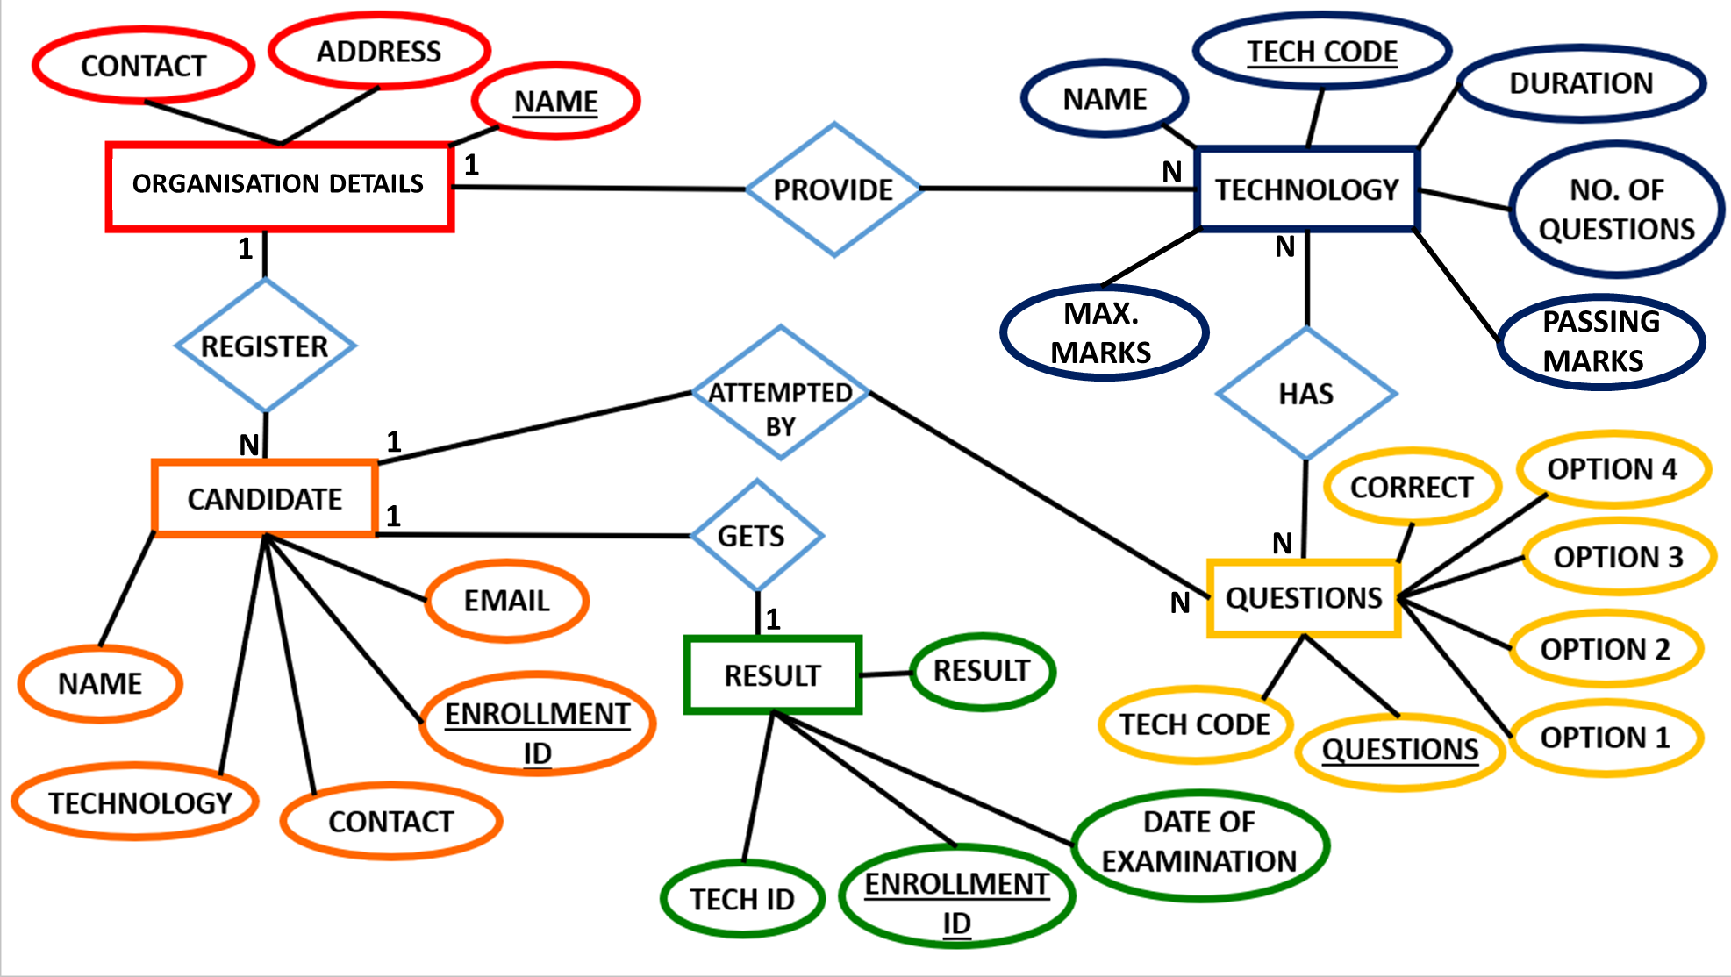

**TECH ID**

**Data Structure: -**

**Organisational Details: -**

|  |  |  |  |  |  |
| --- | --- | --- | --- | --- | --- |
| S No. | Fieldname | Datatype | Size | Constraint | Description |
| 1 | Name | Varchar | 30 | Primary key | --- |
| 2 | Address | Varchar | 50 | Not Null | --- |
| 3 | Contact | Integer | 20 | Not Null | --- |

**Technology: -**

|  |  |  |  |  |  |
| --- | --- | --- | --- | --- | --- |
| S No. | Fieldname | Datatype | Size | Constraint | Description |
| 1 | Name | Varchar | 30 | Not Null | --- |
| 2 | Tech_code | Integer | 11 | Primary key | Technology code |
| 3 | Max_Marks | Integer | 11 | Not Null | Maximum marks |
| 4 | Pass_Marks | Integer | 11 | Not Null | Passing Marks |
| 5 | Duration | Integer | 11 | Not Null | Time duration |
| 6 | N_O_Q | Integer | 11 | Not Null | No. of questions |

**Questions: -**

|  |  |  |  |  |  |
| --- | --- | --- | --- | --- | --- |
| S No. | Fieldname | Datatype | Size | Constraint | Description |
| 1 | Question | Varchar | 500 | Primary key | --- |
| 2 | Tech_code | Integer | 11 | Primary key | Technology code |
| 3 | Option_1 | Varchar | 30 | Not Null | --- |
| 4 | Option_2 | Varchar | 30 | Not Null | --- |
| 5 | Option_3 | Varchar | 30 | Not Null | --- |
| 6 | Option_4 | Varchar | 30 | Not Null | --- |
| 7 | Correct_opt | Varchar | 30 | Not Null | Correct option |

**Candidate: -**

|  |  |  |  |  |  |
| --- | --- | --- | --- | --- | --- |
| S No. | Fieldname | Datatype | Size | Constraint | Description |
| 1 | Enrollment_no | Integer | 11 | Primary key | Enrollment number |
| 2 | Name | Varchar | 30 | Not Null | --- |
| 3 | Technology | Varchar | 30 | Not Null | --- |
| 4 | Email | Varchar | 40 | Not Null | --- |
| 5 | Contact | Integer | 11 | Not Null | --- |

**Result: -**

|  |  |  |  |  |  |
| --- | --- | --- | --- | --- | --- |
| S no. | Fieldname | Datatype | Size | Constraint | Description |
| 1 | Tech_code | Integer | 11 | Primary key | Technology code |
| 2 | Enrollment_no | Integer | 11 | Primary key | Enrollment number |
| 3 | D_O_E | Integer | 11 | Not Null | Date of Examination |
| 4 | Result | Integer | 11 | Primary key | --- |

**Modules:**

* **Number of modules**
* **Process logic of each module**

1. **Number of modules:**

In this project there will be number of modules as follows:

1. **Login module**
2. **Technology details module**
3. **Question details module**
4. **Registration details module**
5. **Examination details module**
6. **Report module**
7. **Process logic of each module:**
8. **Process logic of login module:**

**This module may comprise of following two types of user:**

* + - * 1. User
        2. Administrator

**User module** may comprise of following tasks –

1. Registration of new student
2. Modification of registration details
3. Cancellation of registration
4. Appearing in the examination
5. Change password

The **administrator module** will perform administrative task such as maintaining technologies details, question details, & change password.

1. **Process logic of technologies details module:**

**This module may comprise of following task -**

1. Addition of new-technology details
2. Modification of existing technology details
3. Deletion of any existing technology
4. **Process logic of question details module:**

**This module may comprise of following two types of task: -**

1. Addition of new questions
2. Modification of existing questions
3. Deletion of any existing questions
4. **Process logic of registration details module**

**This module may comprise of following two types of task: -**

1. Addition of new user
2. Modification schedule of an examination
3. Cancellation of an examination
4. **Process logic of examination module:**

**This module may comprise of following two types of task: -**

1. Conduction of an examination
2. Declaring result
3. **Project logic of report module**

**In this module, following types of reports will be generated:**

1. List of all technologies
2. List of all registered students
3. List of all students technology-wise
4. List of all students with their result

**Future Scope of the Project: -**

This is the modern era of technology where everything become online. Internet is connecting more people at a faster rate than ever before. As we know that, many of the coaching institutes and learning centers are also developing interest in conducting online test through the online examination software for their students instead of pen & paper-based exam. It will conduct the exams at ease. It also provides staff arrangement and less administrative duties and it will also provide a global connectivity to the concerned organization. It clearly proves that the online examination software is the future of assessment methodology.

**Bibliography: -**

* Books:

Core Java

Java: A Beginner’s Guide

Effective Java

* Websites:
* Google for problem solving
* [www.tutorialspoint.com](http://www.tutorialspoint.com)
* [www.w3schools.com](http://www.w3schools.com)
* [www.GeekforGeeks.com](http://www.GeekforGeeks.com)
* [www.tutorialspoint.com](http://www.tutorialspoint.com)